|  |  |
| --- | --- |
|  | **SRI VENKATESWARA ENGINEERING COLLEGE**  Karakambadi Road, Tirupati - 517 507, A.P.  Accredited by NAAC, Approved by AICTE & Permanently Affiliated to JNTUA  Recognized under section 2(f) & 12 (B) of UGC act 1956. |

**DEPARTMENT OF ELECTRICAL & ELECTRONICS ENGINEERING**

CONSOLIDATED REPORT ON

**STUDENTS FEEDBACK ON CURRICULUM**

**YEAR:II**

**Academic Year: 2019-20 No of forms Collected: 130**

|  |  |  |  |  |  |  |  |  |
| --- | --- | --- | --- | --- | --- | --- | --- | --- |
| SLNO | Statements | **Excellent-5** | **Very Good-4** | **Good-3** | **Average-2** | **Below Average-1** | **Sum** | **%** |
| 1 | How do you rate the syllabus of the course that you have studied in relation to the competencies expected out of the course? | 79 | 40 | 11 | 0 | 0 | 588 | 90.46 |
| 2 | How do you rate the allocation of credits to the course? | 80 | 40 | 10 | 0 | 0 | 590 | 90.77 |
| 3 | Relevance for implementation in Projects | 75 | 45 | 8 | 2 |  | 583 | 89.69 |
| 4 | How do you rate the electives offered in relation to the technological advancement? | 85 | 35 | 10 |  |  | 595 | 91.54 |
| 5 | How do you rate the evaluation scheme designed for each of the course | 90 | 40 | 10 | 0 |  | 640 | 98.46 |
| 6 | How do you rate the percentage of courses having labs | 82 | 43 | 5 |  |  | 597 | 91.85 |
| 7 | Curriculum is sufficient to make you analyze the engineering problems and its suitable solution | 79 | 41 | 8 | 2 |  | 587 | 90.31 |

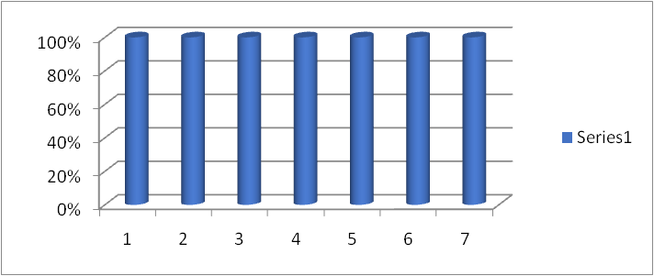

**HOD**

|  |  |
| --- | --- |
|  | **SRI VENKATESWARA ENGINEERING COLLEGE**  Karakambadi Road, Tirupati - 517 507, A.P.  Accredited by NAAC, Approved by AICTE & Permanently Affiliated to JNTUA  Recognized under section 2(f) & 12 (B) of UGC act 1956. |

**DEPARTMENT OF ELECTRICAL & ELECTRONICS ENGINEERING**

CONSOLIDATED REPORT ON

**STUDENTS FEEDBACK ON CURRICULUM**

**YEAR:III**

**Academic Year: 2019-20 No of forms Collected: 90**

|  |  |  |  |  |  |  |  |  |
| --- | --- | --- | --- | --- | --- | --- | --- | --- |
| SLNO | Statements | **Excellent-5** | **Very Good-4** | **Good-3** | **Average-2** | **Below Average-1** | **Sum** | **%** |
| 1 | How do you rate the syllabus of the course that you have studied in relation to the competencies expected out of the course? | 69 | 20 | 1 | 0 | 0 | 428 | 95.11 |
| 2 | How do you rate the allocation of credits to the course? | 66 | 14 | 8 | 2 | 0 | 414 | 92.00 |
| 3 | Relevance for implementation in Projects | 65 | 20 | 3 | 2 |  | 418 | 92.89 |
| 4 | How do you rate the electives offered in relation to the technological advancement? | 65 | 20 | 5 |  |  | 420 | 93.33 |
| 5 | How do you rate the evaluation scheme designed for each of the course | 60 | 25 | 5 | 0 |  | 415 | 92.22 |
| 6 | How do you rate the percentage of courses having labs | 62 | 24 | 4 |  |  | 418 | 92.89 |
| 7 | Curriculum is sufficient to make you analyze the engineering problems and its suitable solution | 63 | 17 | 8 | 2 |  | 411 | 91.33 |

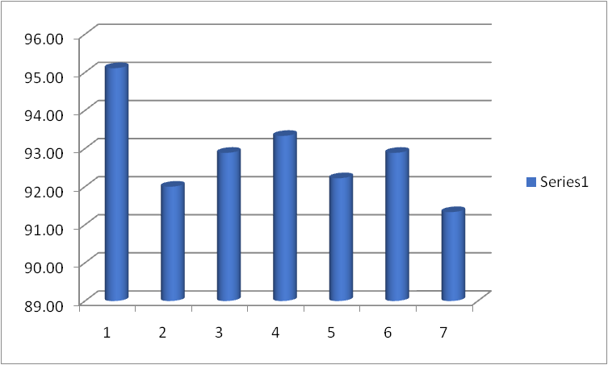

**HOD**

|  |  |
| --- | --- |
|  | **SRI VENKATESWARA ENGINEERING COLLEGE**  Karakambadi Road, Tirupati - 517 507, A.P.  Accredited by NAAC, Approved by AICTE & Permanently Affiliated to JNTUA  Recognized under section 2(f) & 12 (B) of UGC act 1956. |

**DEPARTMENT OF ELECTRICAL & ELECTRONICS ENGINEERING**

CONSOLIDATED REPORT ON

**STUDENTS FEEDBACK ON CURRICULUM**

**YEAR:IV**

**Academic Year: 2019-20 No of forms Collected: 100**

|  |  |  |  |  |  |  |  |  |
| --- | --- | --- | --- | --- | --- | --- | --- | --- |
| SLNO | Statements | **Excellent-5** | **Very Good-4** | **Good-3** | **Average-2** | **Below Average-1** | **Sum** | **%** |
| 1 | How do you rate the syllabus of the course that you have studied in relation to the competencies expected out of the course? | 75 | 23 | 2 | 0 | 0 | 473 | 94.60 |
| 2 | How do you rate the allocation of credits to the course? | 71 | 21 | 6 | 2 | 0 | 461 | 92.20 |
| 3 | Relevance for implementation in Projects | 75 | 20 | 3 | 2 |  | 468 | 93.60 |
| 4 | How do you rate the electives offered in relation to the technological advancement? | 70 | 28 | 2 |  |  | 468 | 93.60 |
| 5 | How do you rate the evaluation scheme designed for each of the course | 68 | 29 | 3 | 0 |  | 465 | 93.00 |
| 6 | How do you rate the percentage of courses having labs | 70 | 26 | 4 |  |  | 466 | 93.20 |
| 7 | Curriculum is sufficient to make you analyze the engineering problems and its suitable solution | 72 | 20 | 8 | 0 |  | 464 | 92.80 |

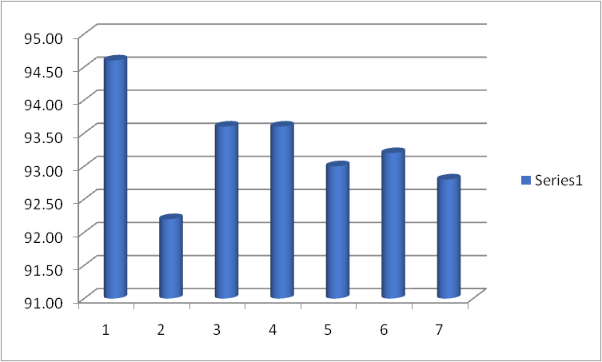

**HOD**